Git & GitHub Assignment
Name: Nishika Soni Course: BTECH-IT
Enrollment No: 2502031030002 Semester : 4
Subject : Web Technology Div : ASOIT – ITA
Task-1: Create a GIT repository named as your enrollment number. Create 2 folder in your repository named as Assignment_1 and Assignment_2.
🔹 Step 1: Create GitHub Account
- Open browser.
- Go to 👉 https://github.com
- Click on Sign Up.
- Enter email, password and complete registration

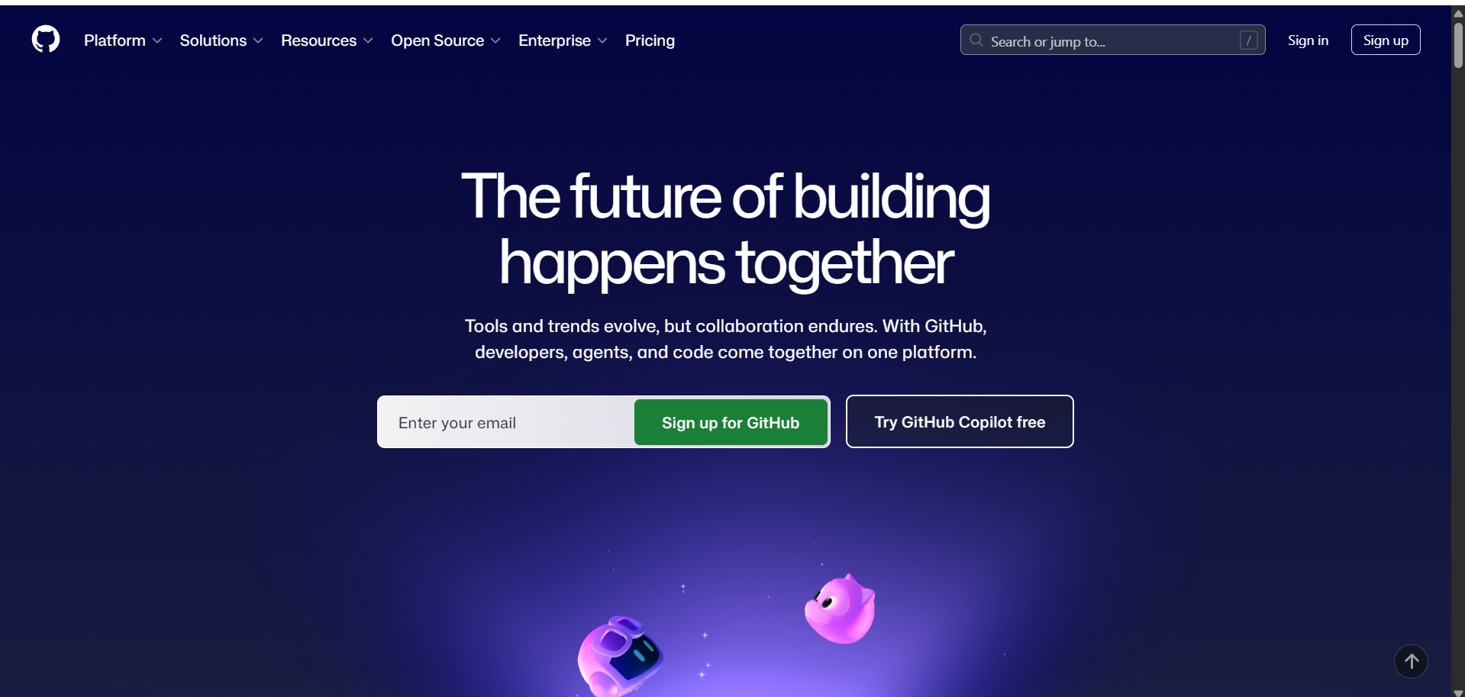

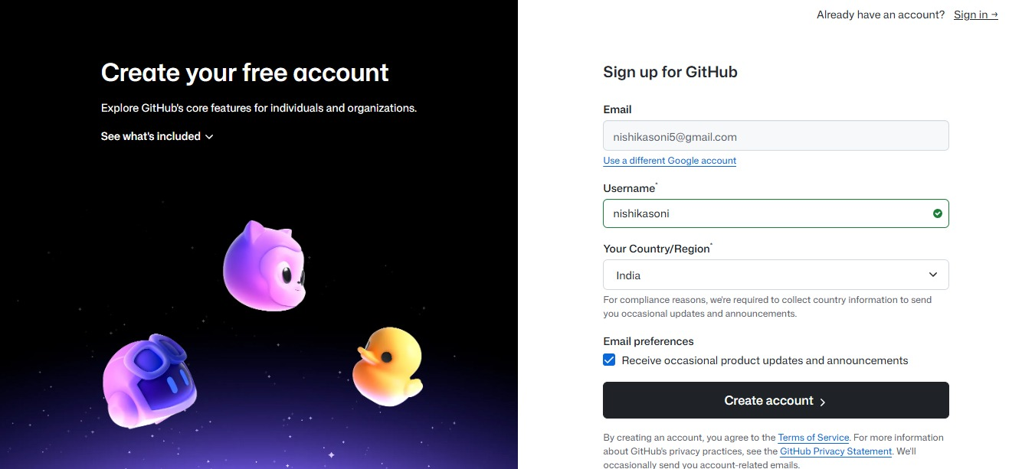

Home Page :
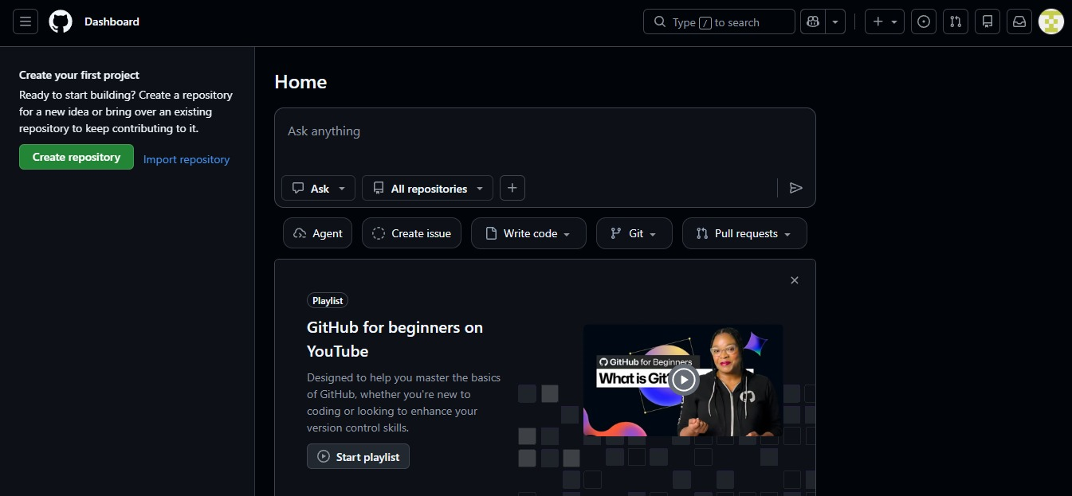

🔹 Step 2: Create New Repository
- Click on New Repository.
- Enter Repository Name = Your Enrollment Number
(Example: 22012345678)
- Select Public.
- Click on Create Repository.

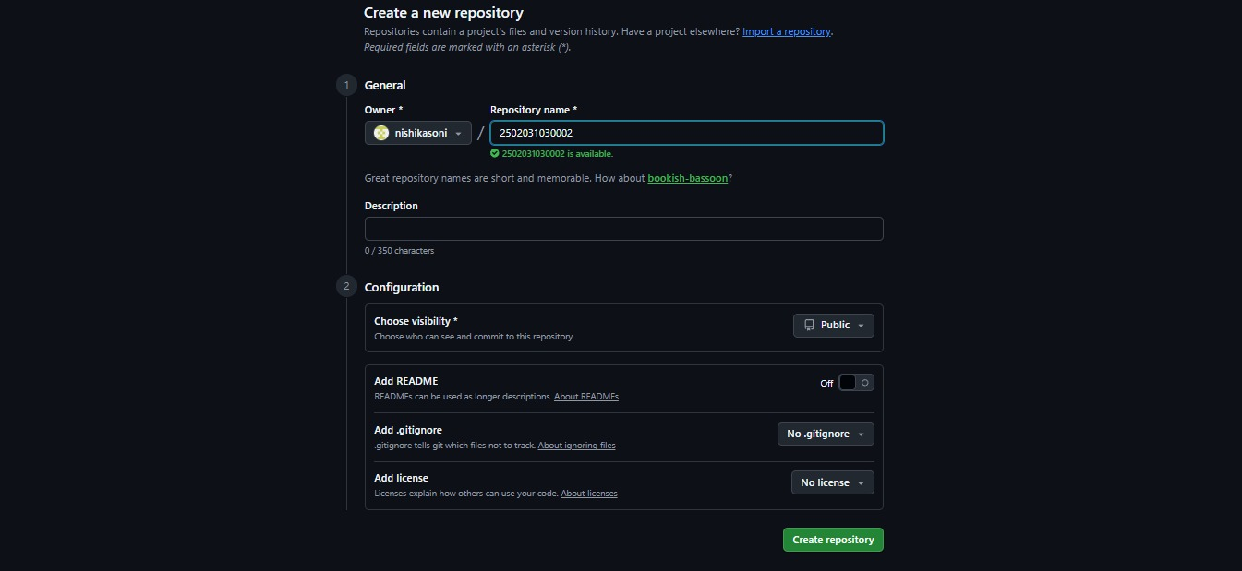
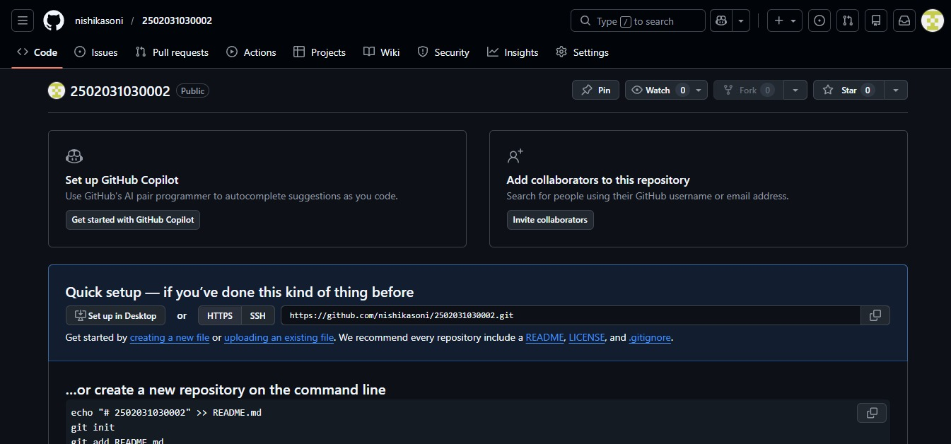
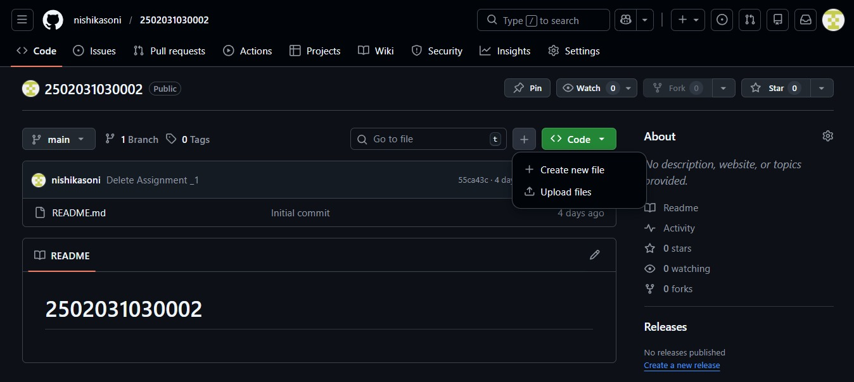

🔹 Step 3: Create Folders
- Open your repository.
- Click on Add File → Create new file.
- Create folder named: Assignment_1
- Create another folder: Assignment_2
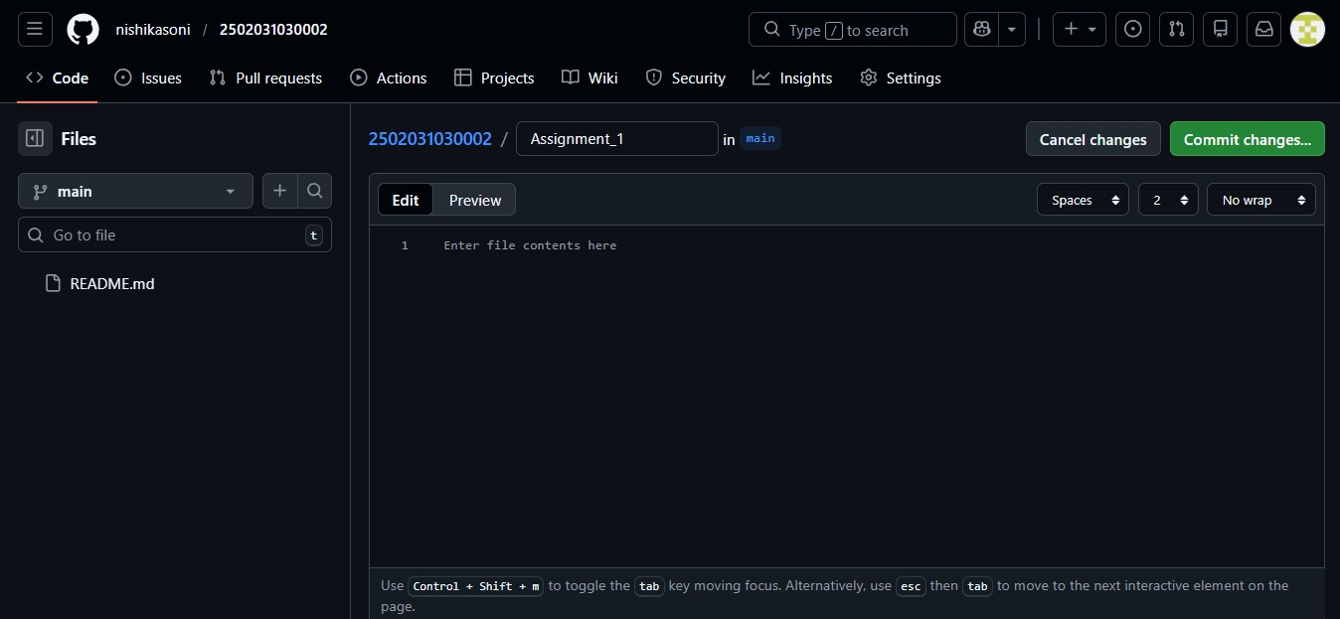
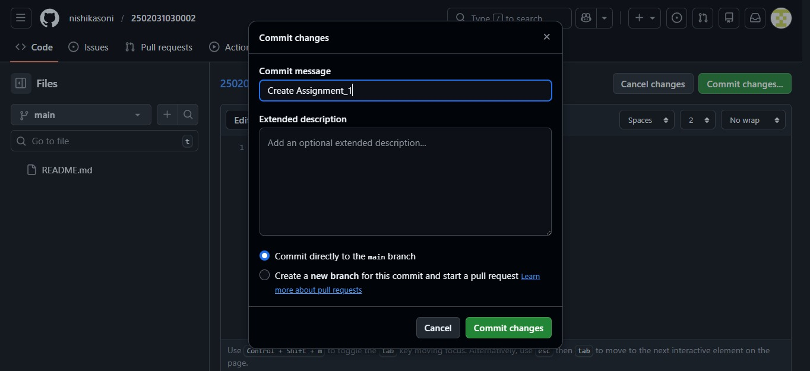
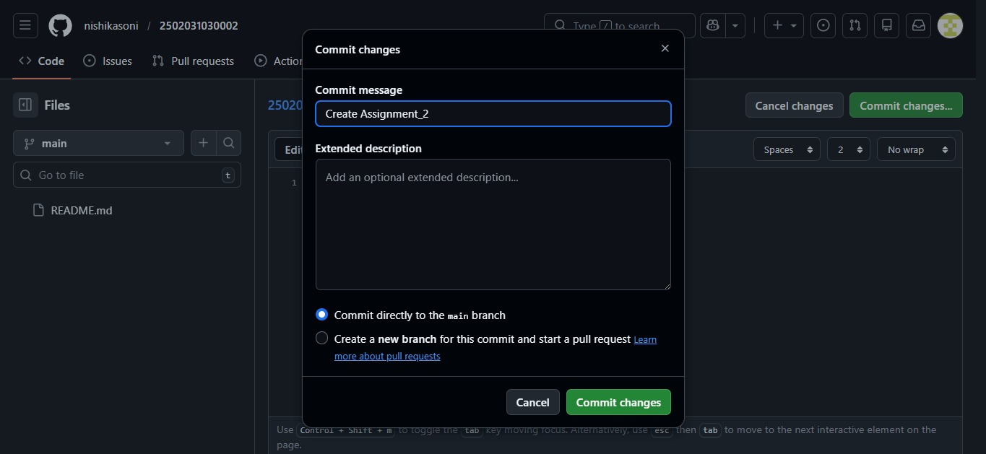
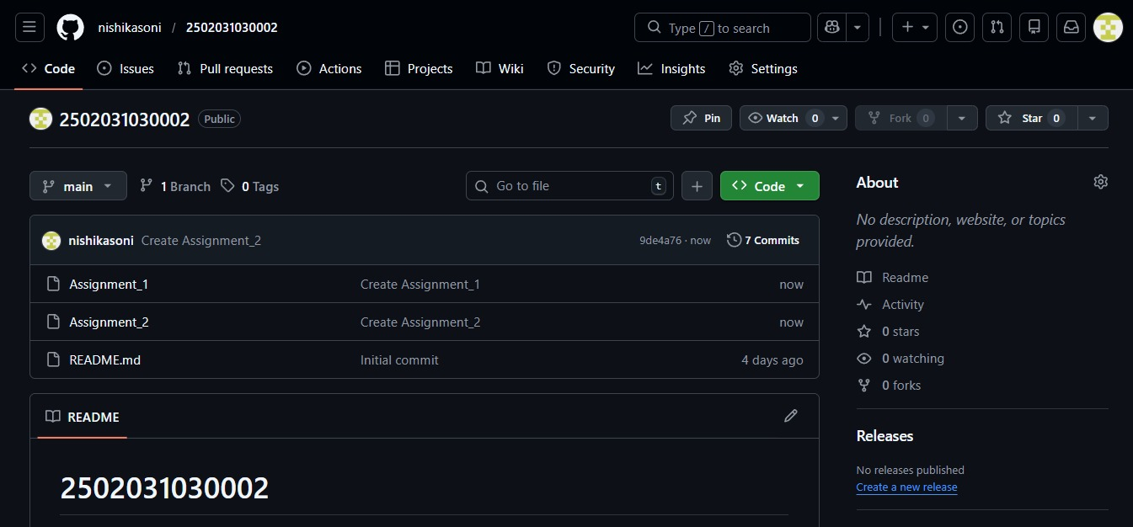
🔹 Step 4: Upload Assignments
- Open Assignment_1 folder.
- Click Upload Files.
- Upload required assignment files.
- Click Commit Changes.
Repeat same process for Assignment_2 folder.
🔹 Step 5: Copy Repository Link
- Go to your repository homepage.
- Copy URL from browser.
Example: https://github.com/username/22012345678
- Paste this link into the provided Google Form.

